AODS-2 Module 4 Workbook

Name:
Date:

Purpose of this workbook:
This task is part of the ADOS-2 (Autism Diagnostic Observation Schedule, Second Edition) assessment process. It is designed to understand how you create stories, describe emotions, and interpret social situations using visual information. This helps us learn more about how you communicate, understand others, and use your imagination. There are no right or wrong answers. Please answer each question with your own thoughts and impressions.

1. DESCRIPTION OF A PICTURE
Image 1

What is happening in this picture?

Why do you think this person is sitting alone?

What do you think this person is feeling or thinking?

How can you tell?

What do you think happened before this moment?

What might happen next?

Image 2

What is happening in this picture?

Why do you think this child is with that man?

What do you think this person is feeling or thinking?

How can you tell?

What do you think happened before this moment?

What might happen next?

Image 3

What is happening in this picture?

Why do you think these people are sitting together?

What do you think these people are feeling or thinking?

How can you tell?

What do you think happened before this moment?

What might happen next?

2. TELL A STORY FROM A BOOK
The following are pages from the visual story The Arrival by Shaun Tan. This wordless graphic novel uses illustrations only to tell a story. The story starts off with a family who leaves their home, please read the book and answer the following questions.
Section 1: Chapter 2, page 12
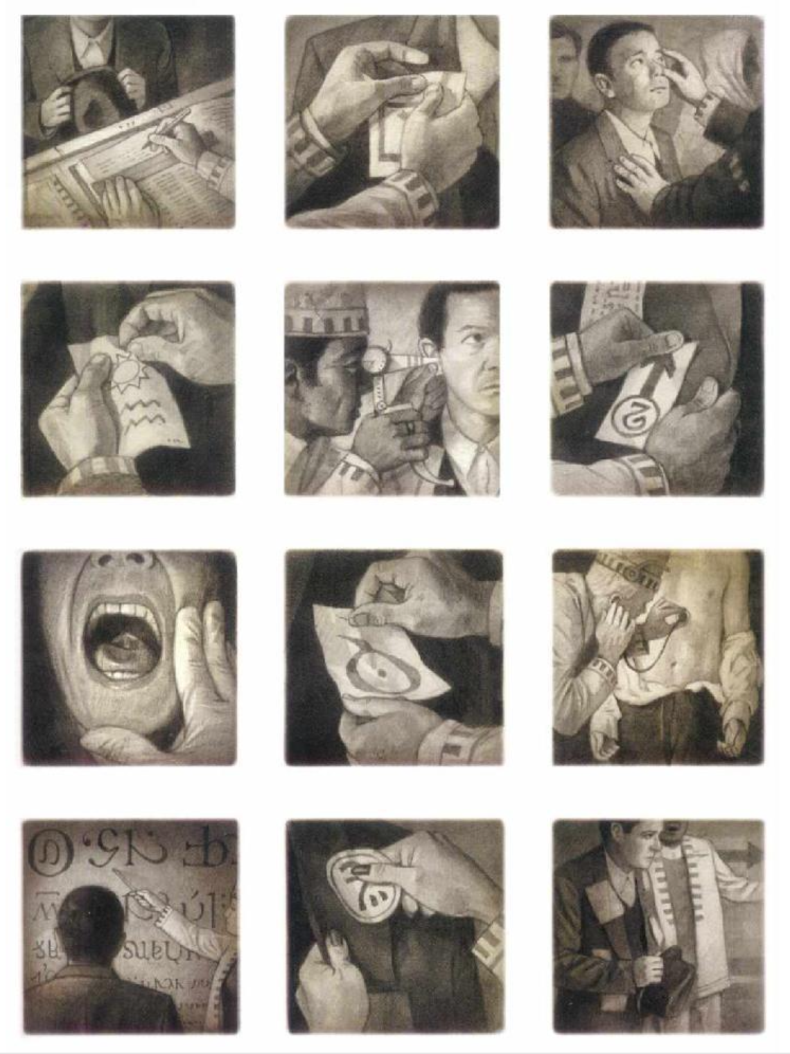
Please describe the story of what’s happening on this page?

Who are the characters?

What are they doing?

Section 2: Chapter 3, page 10
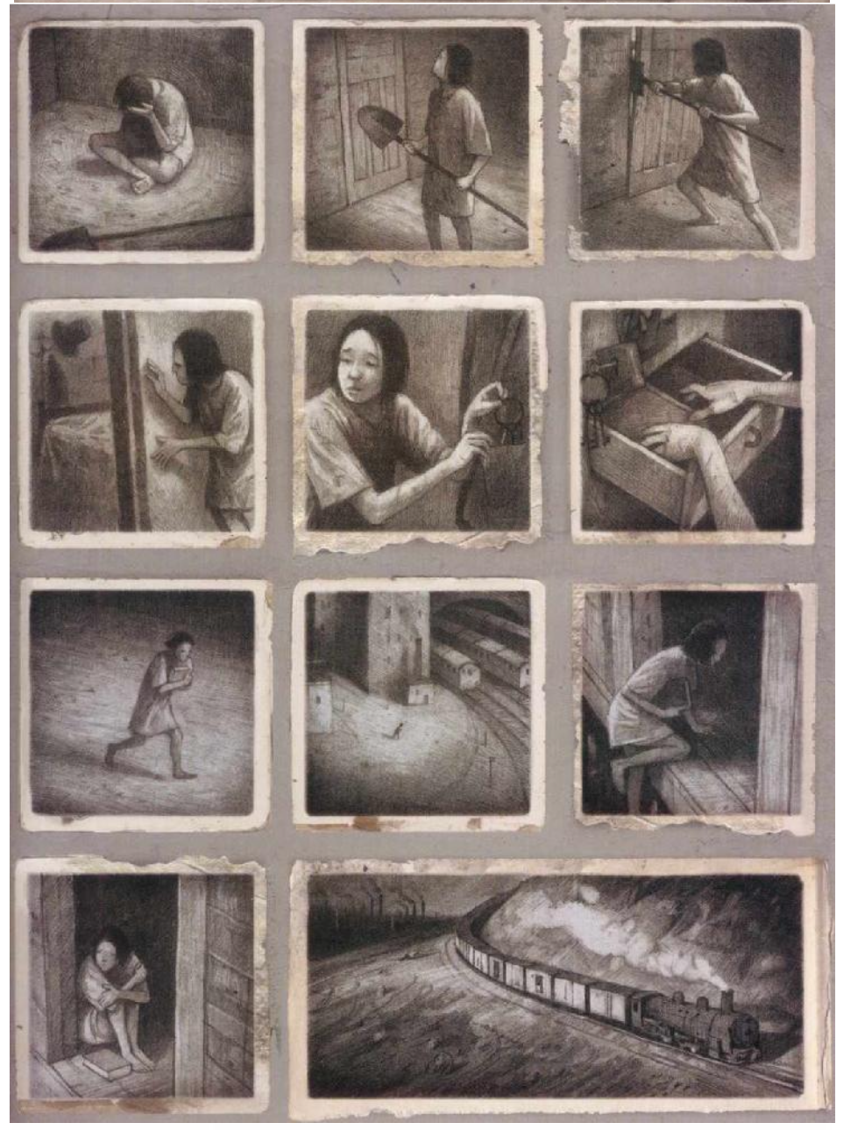
What do you think this character is thinking or feeling?

Why do you think that?

How do you think the other character feels about her situation?

Section 3: Chapter 4, page 14
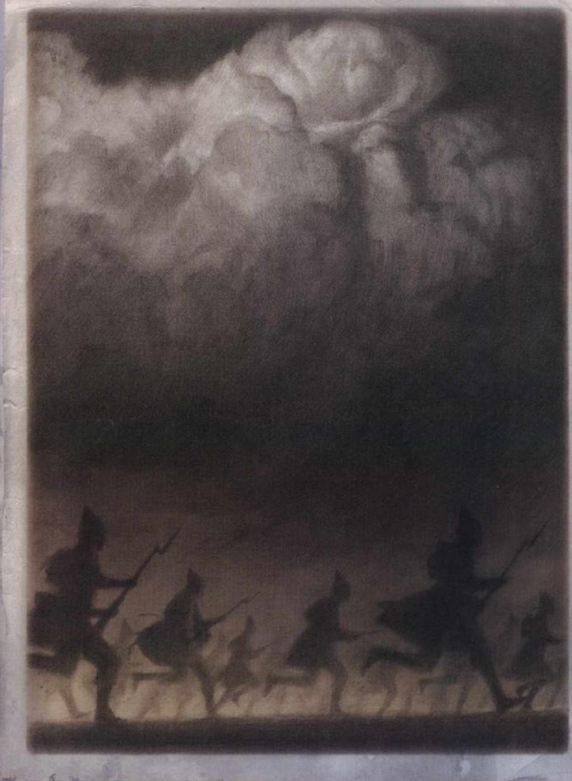
What do you think happened just before this scene?

What do you think might happen next?

If you were one of these characters, what would you do next?

Section 4: Chapter 1, page 5
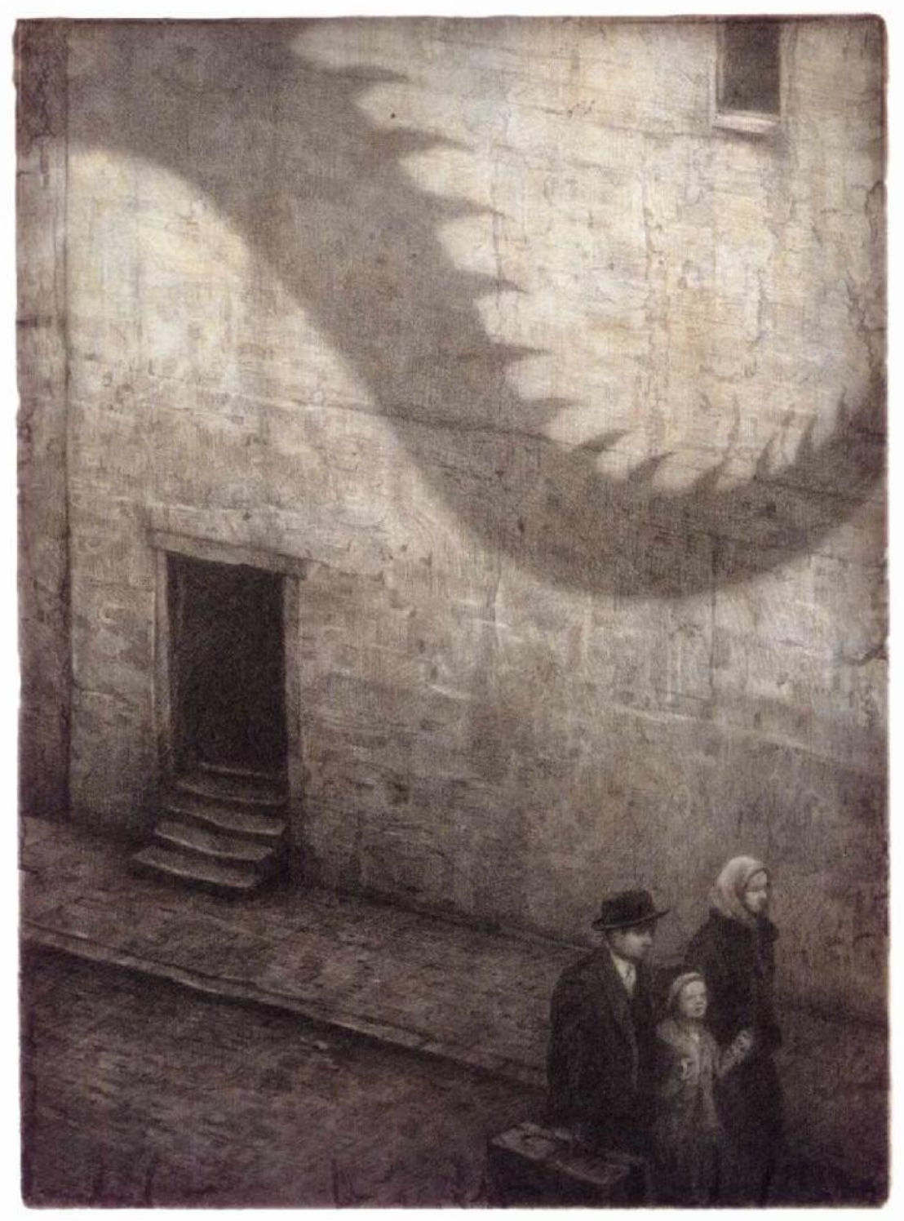
What do you think this monster represents?

Why do you think the artist chose to show this?

What do you think the author is trying to say in this part of the book?

Section 5: Chapter 3, page 7
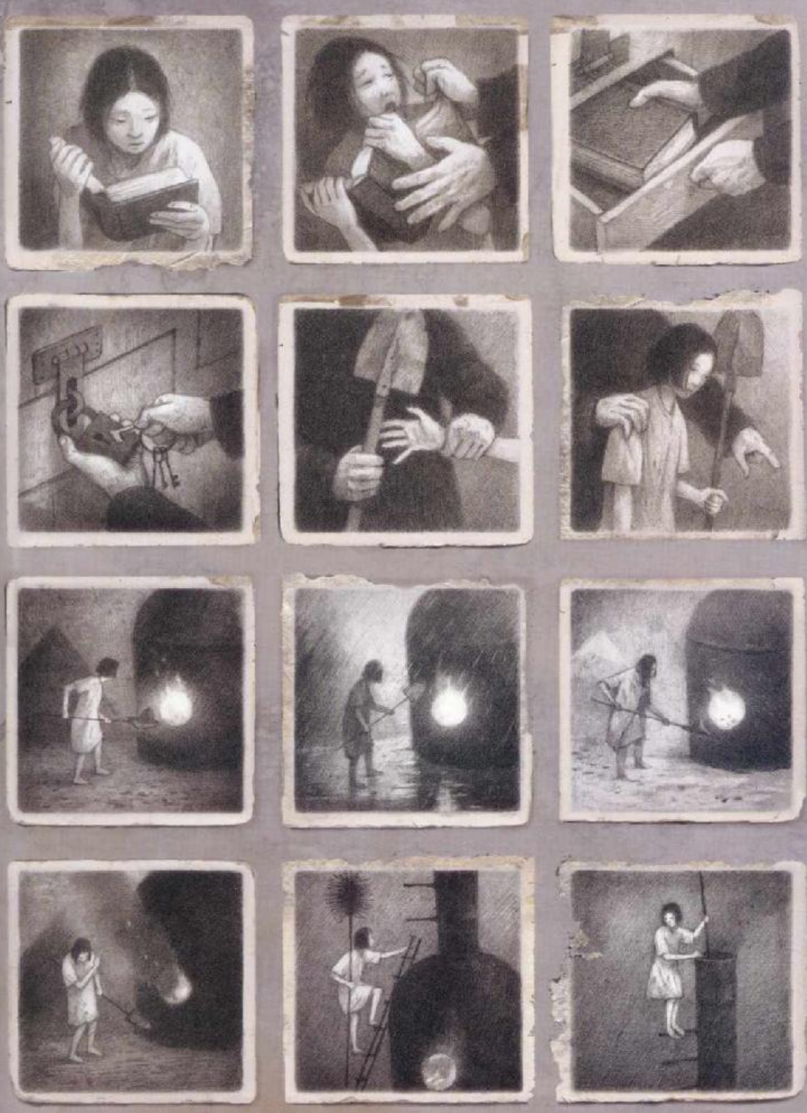
Have you ever felt like this character?

Does this story remind you of anything in your own life or someone else’s?

3. CREATING A STORY
Now you are going to make up stories using some of these objects. To start here is an example of five objects and a story.
The example five objects:
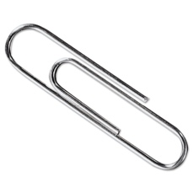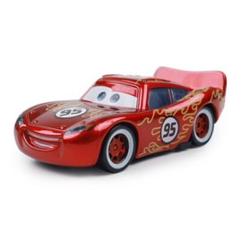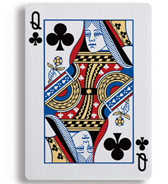

The example story:
The paperclip was a secret agent. It had to drive the toy car to deliver a message hidden in the playing card. On the way, it stopped for lunch and used the spoon to eat invisible soup. But then the rubber band monster appeared! The paperclip used the rubber band to launch itself to safety and finished the mission.”

The five objectives:
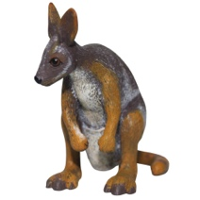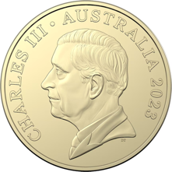
Please write a short story about these five objects:

